1. Brown some Hot Italian sausage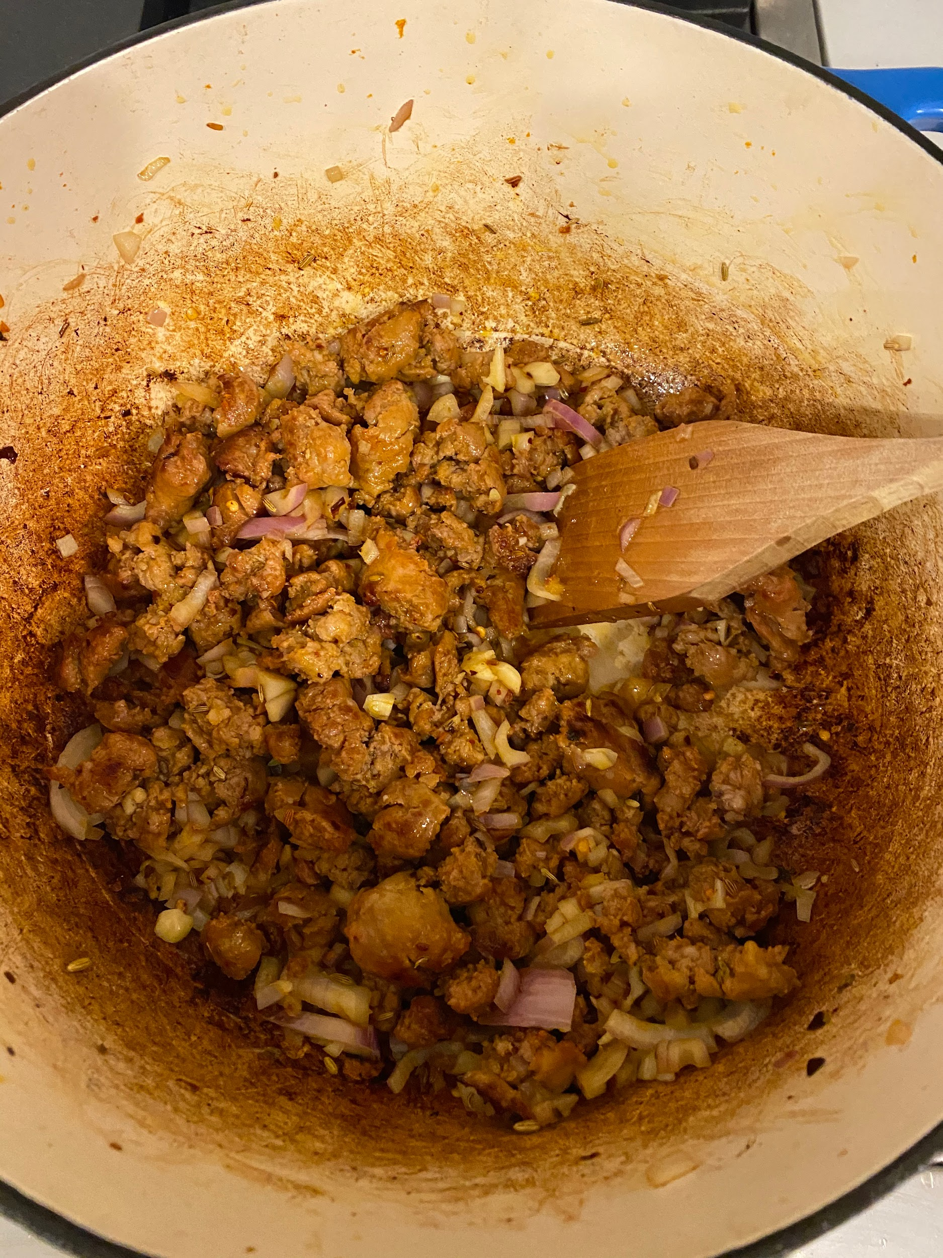
2. Add shallots, garlic, fennel seeds and chili flakes

Should be a dark brown color

1. Add tomato paste

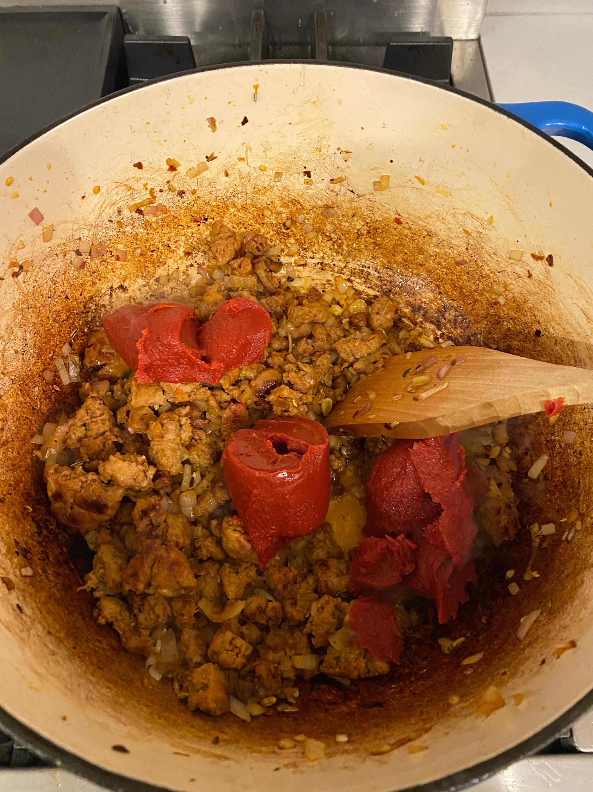

1. Add vodka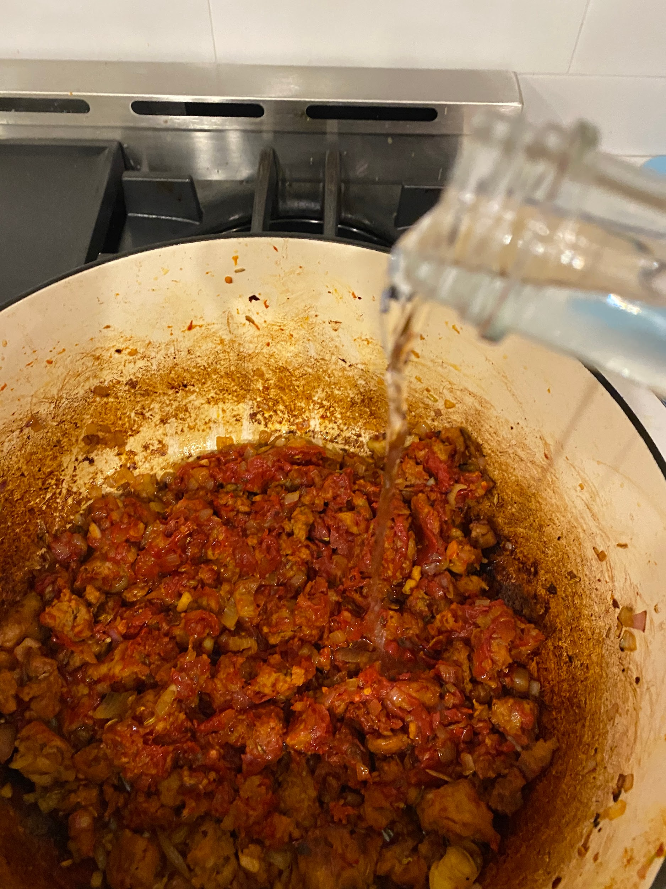
2. Turn off heat. Set on fire. Wait for flames to subside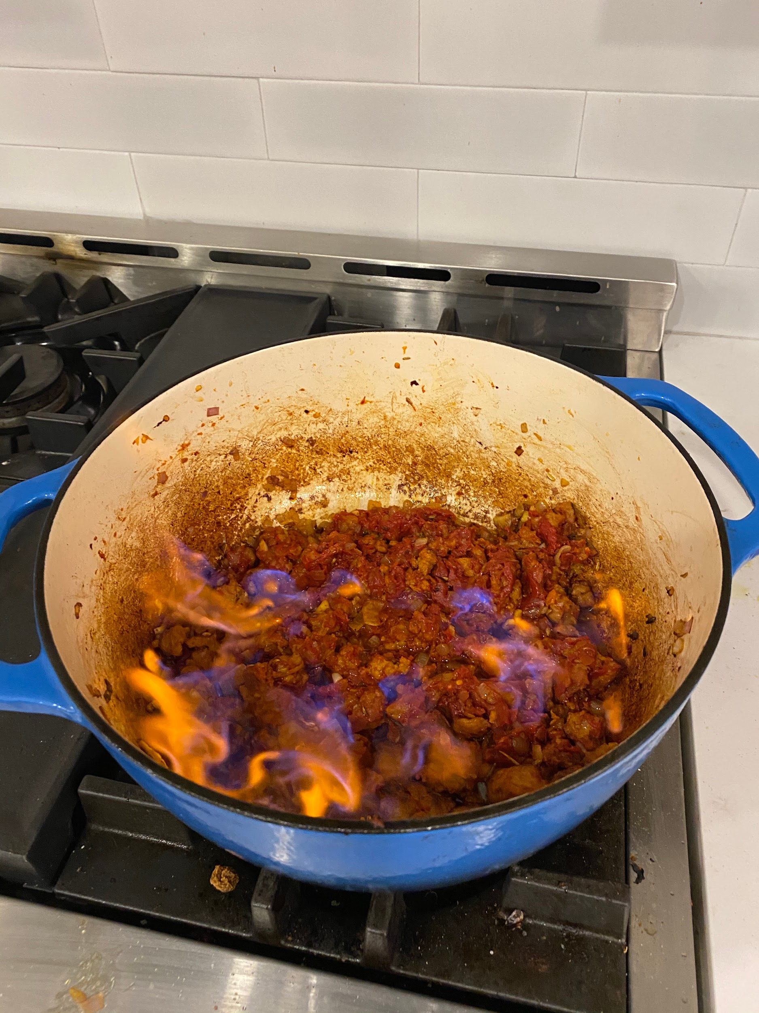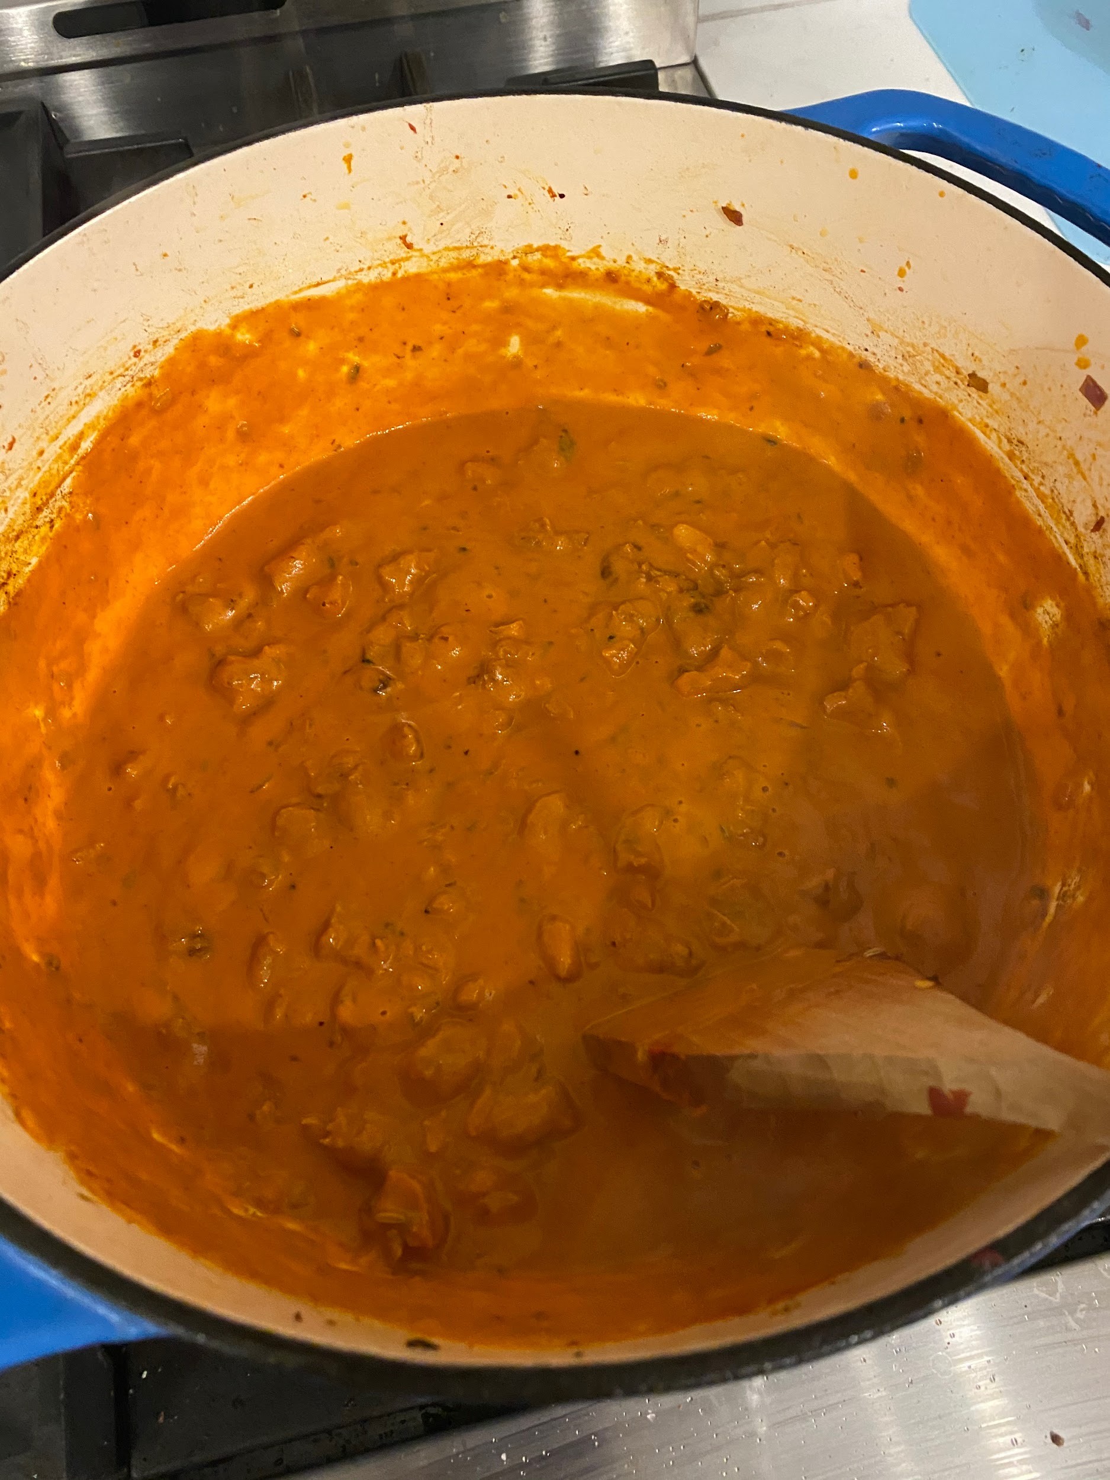
3. Add equal parts cream and beef stock
4. Add ¾ cooks pasta and pasta water
5. Cook gently until pasta is al dente